Policy Name | BACKGROUND CHECKS
Originated | 6/04
Approved By | Board of Directors
Approved On | 8/1/11
Effective Date | 8/15/11
Section | FC 17
Date(s) of Revision | 6/04 old version, 8/05 old version, 7/06 old version, 4/20/07, 5/26/07, 2/25/08, 8/5/08, 1/22/09, 8/29/09, 1/1/10, 3/23/10, 8/1/11
Cross Ref # | FC17.04; AS3.04(c)
Deleted

POLICY |  | As a method of screening, all organization-sponsored individuals over the age of 14 (excluding foster/adoptive children/young adults) who have regular, intermittent, or consistent contact with Refuge House foster children/young adults and/or adoptive children are required to have a background check conducted by Refuge House prior to having contact with foster children/young adults and/or adoptive children. Refuge House requires background checks to be conducted and updated accordingly in order to promote safety within our organization.
APPROVAL |  | Board of Directors
PROCEDURE |  | For all programs and departments within the organization
Additional Information |  | Types of background checks run by Refuge House:  - DPS Criminal Background Checks  - DFPS Central Registry Checks  - FBI Fingerprinting  - ABC Criminal Background Check  - ABC Central Registry Check  - ABC FBI Fingerprint Check  NOTE: Not every individual within the organization requires the same background checks.  Personnel:  - DPS Criminal Background Checks  - DFPS Central Registry Checks  - FBI Fingerprinting (only if they have lived outside the state within the last 5 years)  - ABC Checks (Adoption staff only. The ABC FBI check is only required if the individual has lived outside the state within the last 3 years)  IMPORTANT: There is a $50 fee associated with FBI Fingerprinting. This fee will not be reimbursed to an individual, as it is a prerequisite for employment.  Caregivers:  - DPS Criminal Background Checks  - DFPS Central Registry Checks  - FBI Fingerprinting (unless a caregiver is transferring from another agency, and the state currently has one on record. This will be documented and verified on the results sent back to the organization from the state.)  - Central Registry in other States (If a Caregiver has lived outside the state within the last five years, Refuge House is required to run a central registry check through the child welfare system in that particular state)  NOTE: All household members (excluding foster children) 14 years and older require a DPS and central registry check. Any members 14 to 17 years old do not require an FBI check. All household members ages 18 and above will require an FBI check.  IMPORTANT: There is a $50 fee associated with FBI Fingerprinting. This fee will be reimbursed only if the caregiver is verified and a child/young adult is placed.  IMPORTANT: In order to remain in compliance with all monitoring entities Refuge House conducts background checks every two years on each eligible individual within the Organization.
Responsibility | Step
Caregiver | 1. | The Consent for Background Check Form is returned
Home Developer/HR Director | 2. | All checks must be submitted to the DFPS website in order to run each applicable background check.
DFPS | 3. | Runs all background checks, generating results and e-mailing them to the CEO of Refuge House.
Executive Director/ CEO | 4. | Opens CLASSPROJECT results to allow them to be seen by the HR Director and Home Development Staff of Refuge House.
Home Development/HR Director | 5. | Reviews and verifies that all checks are received and placed in each record. If the check states that the individual(s) required an FBI next steps are taken. However, if one is not required the process ends.
Caregiver/Personnel | 6. | An appointment must be scheduled in order to have FBI Fingerprinting completed. (Using instructions provided by Refuge House)
Executive Director/CEO | 7. | Opens all CLASSPROJECT results allowing HR Director and Home Development to view results.
Home Development/HR Director | 8. | Results are verified and filed in the individuals record.
IMPORTANT: The same process is followed if ABC checks are required as well.
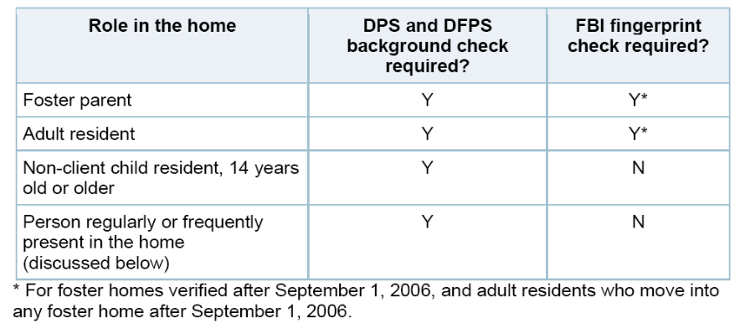
These words have the following meanings:
(1) Frequently--More than two times in a 30-day period.
(2) Regularly--On a scheduled basis.
REFERENCES
DEFINITIONS |  | Caregiver - A person counted in the child/caregiver ratio, including employees, foster/adoptive parents, contract service providers, and volunteers, whose duties include direct care, supervision, guidance, and protection of a child in care. This includes any person that is solely responsible for a child/young adult.
FORMS ATTACHMENTS |  | Request for Background Check Form

